***OS LAB***

***Alagu Soundarya G***

***CB.EN.U4CYS21005***

***22/12/2022***

#include <pthread.h>

#include <stdlib.h>

#include <stdio.h>

#include <unistd.h>

// printWelcomeMessage will be called when the Thread is created in the main function

// which takes string as an argument

void *printWelcomeMessage(void *names) {

sleep(50);

char *name = (char *)names;

printf("\n[THREAD] Hello, Welcome %s.", name);

pthread_exit(NULL);

}

int main () {

// thread defintion

pthread_t threads[7];

// parameter to be passed to the called function - printWelcomeMessage

char names[10][15] = {"Amritha","Praveen","Saurabh","Sangeetha","Lakshmy","Srinivasan","Ramaguru"};

int result;

for(int i = 0; i < 7; i++ ) {

printf("\n[MAIN] Creating thread, %d", i);

// Creating the threading and thus calling the function with parameter passed to it

result = pthread_create(&threads[i], NULL, printWelcomeMessage, (void *)names[i]);

if (result) {

printf("Error in creating thread, %d ", result);

exit(-1);

}

}

// Exit the thread

pthread_exit(NULL);

}

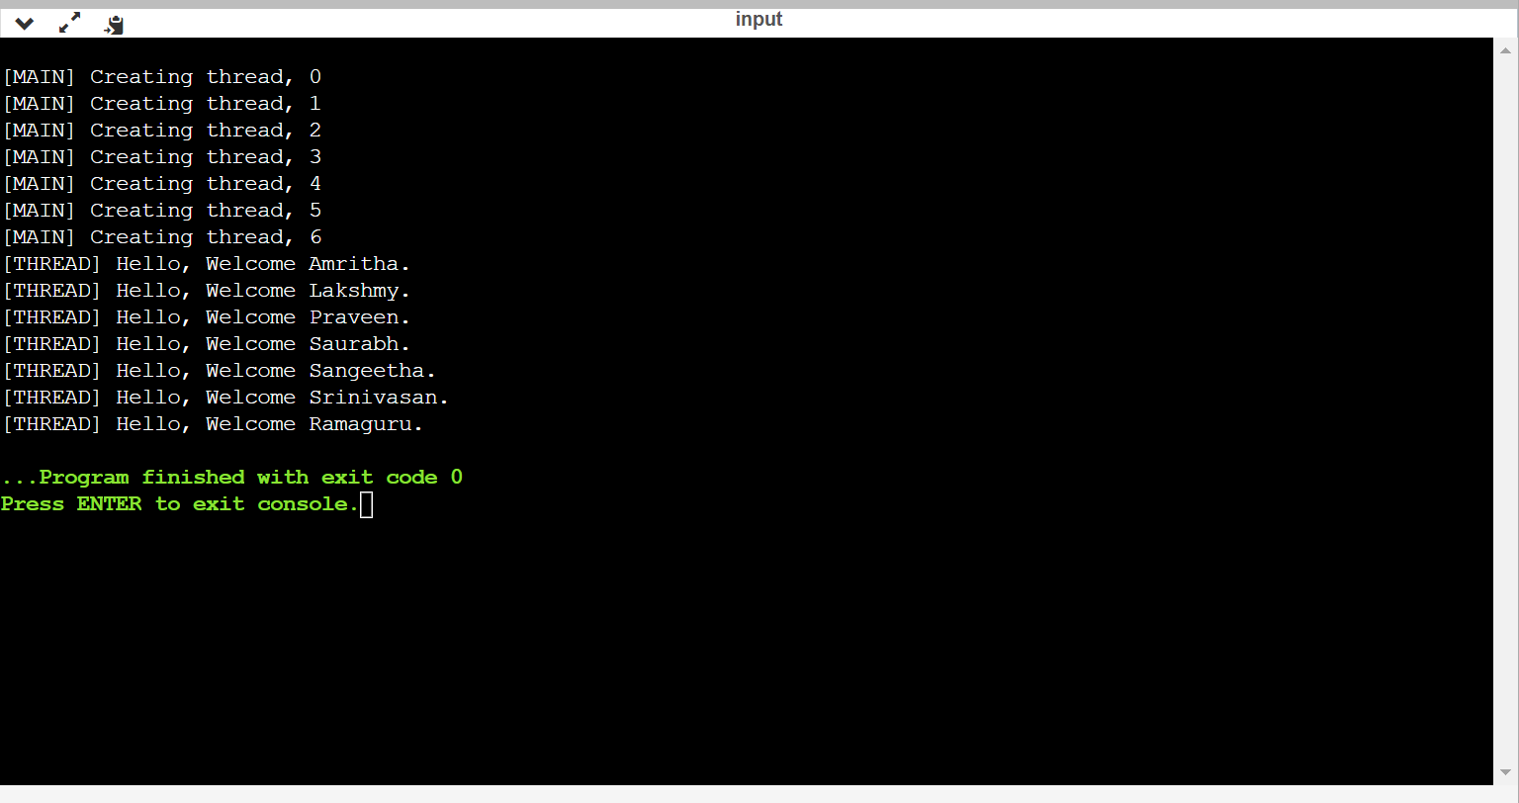

#include <pthread.h>

#include <stdlib.h>

#include <stdio.h>

#include <unistd.h>

// printWelcomeMessage will be called when the Thread is created in the main function

// which takes string as an argument

void *printWelcomeMessage(void *threadid) {

sleep(1);

long tid=(long)threadid;

printf("\n[THREAD] Hello, Welcome %ld.", tid);

pthread_exit(NULL);

}

int main () {

// thread defintion

pthread_t threads[7];

// parameter to be passed to the called function - printWelcomeMessage

char names[10][15] = {"Amritha","Praveen","Saurabh","Sangeetha","Lakshmy","Srinivasan","Ramaguru"};

int result;

for(int i = 0; i < 7; i++ ) {

printf("\n[MAIN] Creating thread, %d", i);

// Creating the threading and thus calling the function with parameter passed to it

result = pthread_create(&threads[i], NULL, printWelcomeMessage, (void *)&threads[i]);

if (result) {

printf("Error in creating thread, %d ", result);

exit(-1);

}

}

// Exit the thread

pthread_exit(NULL);

}

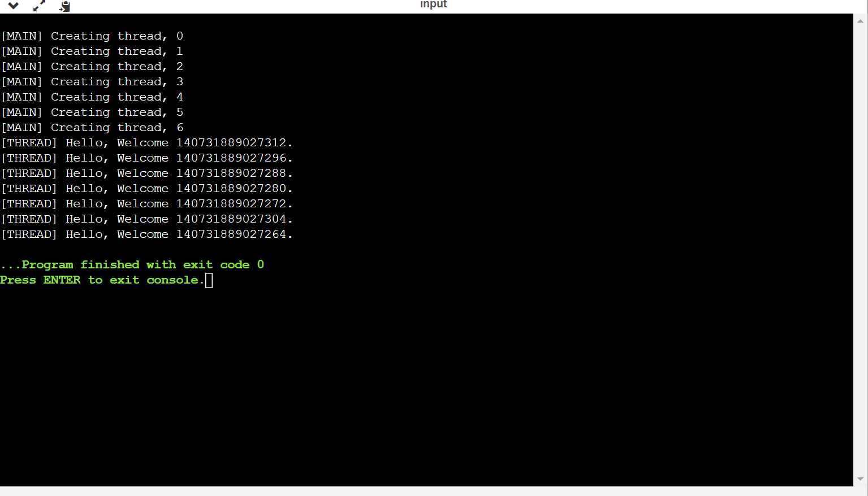

#include <pthread.h>

#include <stdlib.h>

#include <stdio.h>

#include <unistd.h>

// printWelcomeMessage will be called when the Thread is created in the main function

// which takes string as an argument

void *addition() {

int value1;

int value2;

printf("Enter the 1st element:");

scanf("%d",&value1);

printf("Enter the 2nd element:");

scanf("%d",&value2);

int total = value1 + value2;

printf("%d",total);

}

int main () {

// thread defintion

pthread_t threads;

int result;

// Creating the threading and thus calling the function with parameter passed to it

result = pthread_create(&threads, NULL, addition, NULL);

if (result) {

printf("Error in creating thread, %d ", result);

exit(-1);

}

// Exit the thread

pthread_exit(NULL);

}

